Lab Objectives
By the end of this lab, students will be able to:
- Install the XIAO nRF52840 Sense board package.
- Install the IMU library.
- select the correct board and serial port.
- Send text from the XIAO to the computer.
- Read accelerometer and gyroscope measurements.
- Display IMU measurements on the Arduino Serial Monitor.

Part 1: Install the Required Board Package and Library

Step 1: Add the Seeed Board Manager URL
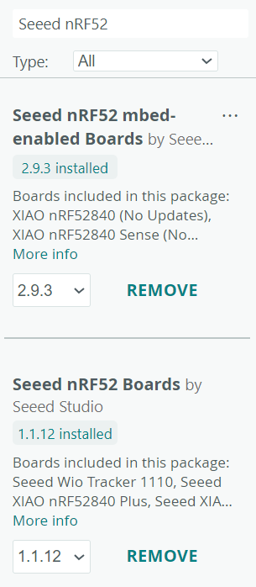
- Open Arduino IDE.
- Select:
File → Preferences
- Find Additional Boards Manager URLs.
- Add the following address:
https://files.seeedstudio.com/arduino/package_seeeduino_boards_index.json
- Click OK.

Step 2: Install the XIAO Board Package
- Select:
Tools → Board → Boards Manager
- Search for:
Seeed nRF52
- Install: both NRF boards for this lab, use the mbed-enabled board package.

Step 3: Select the Board
Connect the XIAO nRF52840 Sense to the computer using the USB cable.
In Arduino IDE, select:
Tools → Board → Seeed nRF52 mbed-enabled Boards
Then select:
Seeed XIAO nRF52840 Sense Plus
Be careful not to select the normal XIAO nRF52840 board. The normal board does not contain the onboard IMU.
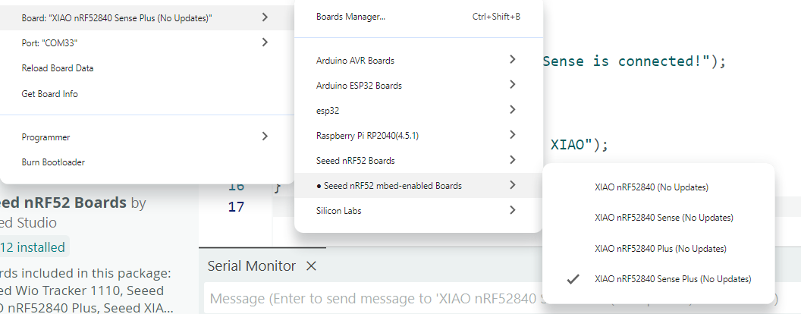

Step 4: Select the Serial Port
Select:
Tools → Port
Choose the port connected to the XIAO. On Windows, it will normally appear as something similar to:
COM3
COM4
COM5
The port number may be different on each computer.

Checkpoint 1
Before continuing, confirm that:
- The board package is installed.
- Seeed XIAO nRF52840 Sense Plus is selected.
- A serial port is visible and selected.

Step 5: Install the IMU Library
Open:
Sketch → Include Library → Manage Libraries
Search for:
Seeed Arduino LSM6DS3
Install the library published by Seeed Studio.

Alternative ZIP Installation
When the library does not appear in Library Manager:
- Download the Seeed_Arduino_LSM6DS3 ZIP file.
- In Arduino IDE, select:
Sketch → Include Library → Add .ZIP Library
- Select the downloaded ZIP file.

Part 2: Test Serial Communication
Before using the IMU, confirm that the XIAO can send information to the computer.

Step 1: Create a New Sketch
Select:
File → New Sketch
Delete the existing code and enter:
void setup() {
// Start USB serial communication
Serial.begin(115200);
// Wait until the Serial Monitor is opened
while (!Serial) {
delay(10);
}
Serial.println("XIAO nRF52840 Sense is connected!");
}
void loop() {
Serial.println("Hello from the XIAO");
delay(1000);
}

Step 2: Open the Serial Monitor
Open:
Tools → Serial Monitor
Alternatively, click the Serial Monitor icon in the upper-right corner of Arduino IDE.
Set the baud rate to:
115200
You should see:
XIAO nRF52840 Sense is connected!
Hello from the XIAO
Hello from the XIAO
Hello from the XIAO
A new message should appear approximately once every second.

Checkpoint 2
Serial communication is working when:
- The sketch uploads successfully.
- The correct COM port is selected.
- Messages appear in the Serial Monitor.
- The baud rate is set to 115200.

Part 3: Start the IMU
The onboard IMU measures:
Measurement | Axes | Typical unit
Acceleration | X, Y and Z | g
Angular velocity | X, Y and Z | degrees per second
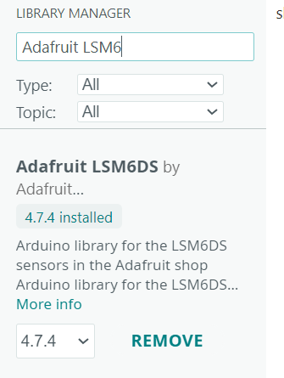
The accelerometer detects movement and gravity. The gyroscope detects rotational movement.
Down load Adafruit library And add it: https://github.com/adafruit/Adafruit_LSM6DS

Step 3.1: Upload the IMU Program
Create a new sketch and enter the following code:

Code attached

Step 3.2: Observe the Measurements
- Upload the program.
- Open the Serial Monitor.
- Set the baud rate to 115200.
- Keep the board stationary.
- Move the board in different directions.
- Rotate the board around each axis.
Example output:
Starting XIAO nRF52840 Sense IMU...
IMU started successfully.
Accelerometer
AX: 0.021 g AY: -0.014 g AZ: 1.002 g
Gyroscope
GX: 0.31 deg/s GY: -0.28 deg/s GZ: 0.15 deg/s
------------------------------
When the board is resting flat, one accelerometer axis will normally measure approximately 1 g because of gravity.
When the board is rotated, the gyroscope values should change.

Checkpoint 3
The IMU is operating correctly when:
- IMU started successfully appears.
- Six values appear on the Serial Monitor.
- Accelerometer values change when the board is moved.
- Gyroscope values change when the board is rotated.

Troubleshooting

The Port Does Not Appear
- Disconnect and reconnect the USB cable.
- Try another USB cable.
- Try another USB port.
- Press the reset button once.
- If necessary, press the reset button twice quickly to enter bootloader mode.
- Check Tools → Port again.

The Program Does Not Upload
Confirm that the selected board is:
Seeed XIAO nRF52840 Sense Plus
under:
Seeed nRF52 mbed-enabled Boards
Also close the Serial Monitor before uploading again.

Nothing Appears in the Serial Monitor
Check the following:
- Correct COM port selected
- Baud rate set to 115200
- Serial Monitor opened after uploading
- USB cable supports data
- Board reset once after uploading

Student Exercise
Modify the IMU program so that it:
- Reads the accelerometer every 100 ms.
- Displays only AX, AY and AZ.

